II B. Tech. II Semester Regular Examinations – May, 2023
COMPUTER NETWORKS
Time: 150 Min CSE (CS) Max. Marks:80M

SECTION – A
Answer all Four questions 4×10M=40M

1. a) Describe what TCP slow start means.
b) When a TCP sender receives a triple duplicate ACK, its congestion window (CongWin) is cut in half, then grows linearly. However, when a TCP sender experiences a timeout event, it employs a new slow start. Explain the philosophy behind this different treatment of observed data loss.
c) Explain the terms additive increase and multiplicative decrease in the context of TCP congestion control.
d) Explain what will happen when two applications (one using TCP, the other using UDP) that want to send as much data as possible compete for bandwidth.

2. a) Consider the network of five routers below, with edge weights labeled. Show the step-by-step operation of Dijkstra’s algorithm for R3 using the table
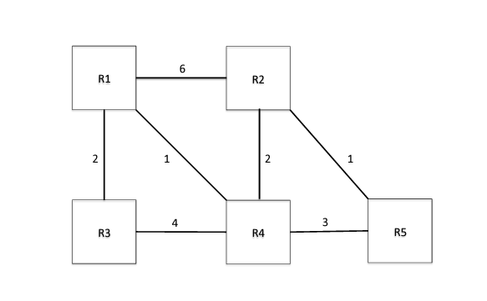
b) Now consider a Bellman-Ford-based distance-vector protocol that uses split horizon and poison reverse. Assume that the protocol has converged, and then node R5 fails. Will the protocol reconverge? If so, show the sequence of updates that result. (After each update, show the nexthop and cost for R5 as seen by each of the remaining routers.) If not, explain why not.

3. Assume that you want to retrieve a webpage that references 9 very small objects.
a) When using non-persistent HTTP with no parallel TCP connections, how much time elapses from when the client requests the webpage until the entire webpage comes in? How many messages will the client and the server exchange before the entire webpage is received by the client’s host?
b) How long would the client wait before the entire webpage is received under persistent HTTP with no pipelining? How many messages must be sent in this case?
c) How long does the client wait until it obtains the entire webpage when using non-persistent HTTP with a maximum of 5 parallel connections?
d) How long does the client wait until it obtains the entire webpage under persistent HTTP with a maximum of 5 pipelined requests?

4. Assume you are given to LAN scenario below:
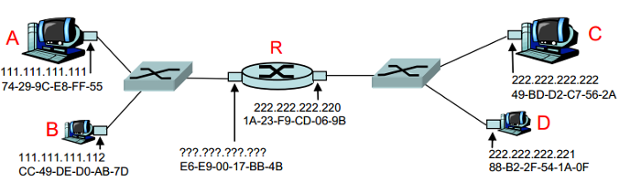
a) Assign an IP address to the leftmost interface of the router, given that the subnet part of IP addresses are 24 bits.
b) Suppose A wants to send an IP datagram to B and knows B’s IP address. Must A also know B’s MAC address to send the datagram to B? If so, how does A get this info? If not, explain why not.
c) Suppose A wants to send an IP datagram to C and knows C’s IP address. Must A also know C’s MAC address to send the datagram to C? If so, how does A get this info? If not, explain why not.
d) Suppose that R has a datagram (that was originally sent by A) to send to C. What are the MAC addresses on the frame that is sent from R to C? What are the IP addresses in the IP datagram encapsulated within this frame?

SECTION -B
Answer all Two questions 2×20M=40M
5. a) Ethernet protocol uses CSMA/CD for multiple access control. When a collision is detected, how does Ethernet back off to avoid future collisions? What is the advantage of this scheme compared to random backoff?
b) Why doesn’t collision detection work well in wireless networks? (describe a scenario where this doesn’t work.)
c) Why are acknowledgments used in 802.11 but not in wired Ethernet?
d) Suppose nodes A and B are on the same 10Mbps Ethernet segment and the propagation delay between the two nodes is 225 bit times. Suppose A and B send frames at the same time, the frames collide, and then A and B choose different values of K in the CSMA/CD algorithm. Assuming no other nodes are active, can the retransmissions from A and B collide? Assuming A chooses K=0, B chooses K=1, basically we need to find out whether A’s retransmission will reach B before B’s scheduled retransmission time.
e) In the CSMA/CA protocol, a station that successfully transmits a frame begins the protocol for a second frame at step 2 where its adapter has to sense the channel idle for 96 bit times before it can start transmitting again. What is the rationale behind this? Why not allow the station transmit the second frame immediately, if the channel is sensed idle?

6. Consider an application that transmits data at a steady rate (for example, the sender generates an N-bit unit of data every k time units, where k is small and fixed). Also, when such an application starts, it will continue running for a relatively long period of time. Answer the following questions, briefly justifying your answer:
a) Would a packet-switched network or a circuit-switched network be more appropriate for this application? Why?
b) Suppose that a packet-switched network is used and the only traffic in this network comes from such applications as described above. Furthermore, assume that the sum of the application data rates is less than the capacities of each and every link. Is some form of congestion control needed? Why?

c) Consider the circuit-switched network below figure. Recall that there are 4 circuits on each link. Label the four switches A, B, C, and D, going in the clockwise direction.

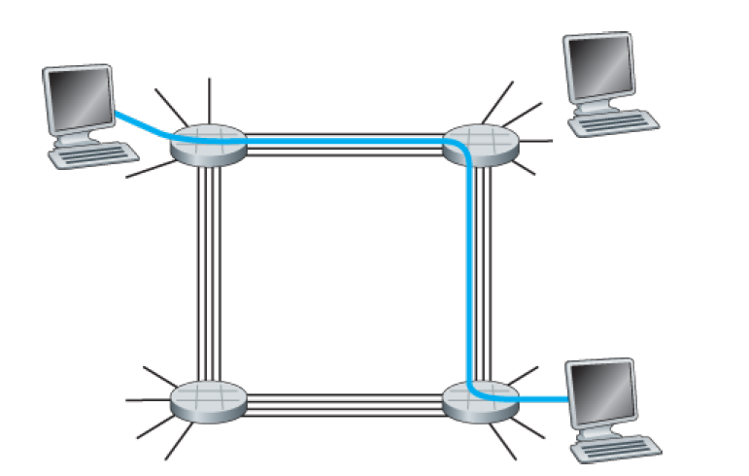
i) What is the maximum number of simultaneous connections that can be in progress at any one time in this network?
ii) Suppose that all connections are between switches A and C. What is the maximum number of simultaneous connections that can be in progress?
iii) Suppose we want to make four connections between switches A and C, and another four connections between switches B and D. Can we route these calls through the four links to accommodate all eight connections?

